Assignmnet-1

Machine learning _TOPIC ( Simple and multilinear regression)

Date: 15-09-2019

Qn:1 ) From a study , the effect of the mole ratio of sebacic acid on the intrinsic viscosity of copolyesters given below:

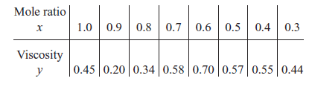

Calculate the following

1. Construct a scatter diagram for the given data
2. Compute the Rankine correlation coefficient of the given data
3. Fit a simple linear regression module
4. Calculate the predicted value for viscosity for mole ratio 0.225
5. Test for significance of regression. Calculate R2 for the model
6. Analyze the residuals and comment on model adequacy.

Qn: 2) Consider the data on two variables y and x shown below. Fit a simple linear regression model and test for lack of fit, using α = 0.05.

The data follow:

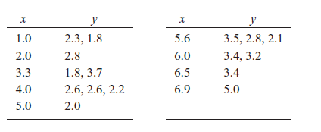

Prepare the regression equation and SSR of above data

Qn: 3) The electric power consumed each month by a chemical plant is thought to be related to the average ambient temperature (x1), the number of days in the month (x2), the average product purity (x3), and the tons of product produced (x4). The past year’s historical data are available and are presented in the attached excel sheet:

1. Fit a multiple linear regression model to these data.
2. Estimate variance.